To make the communication effective involvement of all persons are required. But the Persons with Disabilities or Divyangjan face difficulties in the conversation to understand the other’s language specially when they have hearing loss. The Human-Computer Interaction Technology converts the sign into the text, and this approach will surely provide the solution for discussed problem, Here the proposed solution based on gesture recognition will convert the sign into the text. So that Divyangjan will be able to respond to his partner by understanding his point of view through his signal.

The Approach is based on MediaPipe library to recognize the hand and the hand key points. There are total 21 key points in the palm for each detected hand. First the palm will be detected on the full image and returns an oriented hand bounding box. A hand landmark model returns high fidelity 3D hand key-points (21 key Points). A gesture recognizer computed key-point into a discrete set of gestures and will display on the screen.

* The Approach is based on MediaPipe library to recognize the hand and the hand key points. There are total 21 key points in the palm for each detected hand.
* First the palm will be detected on the full image and returns an oriented hand bounding box.
* A hand landmark model returns high fidelity 3D hand keypoints (21 key Points).
* A gesture recognizer computed keypoint into a discrete set of gestures and will display on the screen.

. Summary: 1.The main barrier to communication for people who are hearing impaired is the lack of consideration by others. 2.There is an urgent requirement to include all humans into the society as per the ratification of the UNCRPD act. 3.Considering the wealth of information that is being circulated, the persons with hearing impairment may lag behind if they are unable to access this information, some of which may be vital and urgent. Objective: Develop solutions for real time provision of closed and open captioning, subtitles for videos, text telephone which will allow text messaging over the phone line, and telecommunications relay services which allow text to speak conversions through an operator."

Gesture recognition is an active research field in Human-Computer Interaction technology. It has many applications in virtual environment control and sign language translation, robot control, or music creation. In this machine learning project on Hand Gesture Recognition, we are going to make a real-time Hand Gesture Recognizer using the MediaPipe framework and Tensorflow in OpenCV and Python.

The ability to perceive the shape and motion of hands can be a vital component in improving the user experience across a variety of technological domains and platforms. For example, it can form the basis for [sign language](https://en.wikipedia.org/wiki/American_Sign_Language) understanding and hand gesture control, and can also enable the overlay of digital content and information on top of the physical world in [augmented reality](https://ai.googleblog.com/search/label/Augmented%20Reality). While coming naturally to people, robust real-time hand perception is a decidedly challenging computer vision task, as hands often occlude themselves or each other (e.g. finger/palm occlusions and hand shakes) and lack high contrast patterns.

MediaPipe to recognize the hand and the hand key points. MediaPipe returns a total of 21 key points for each detected hand.

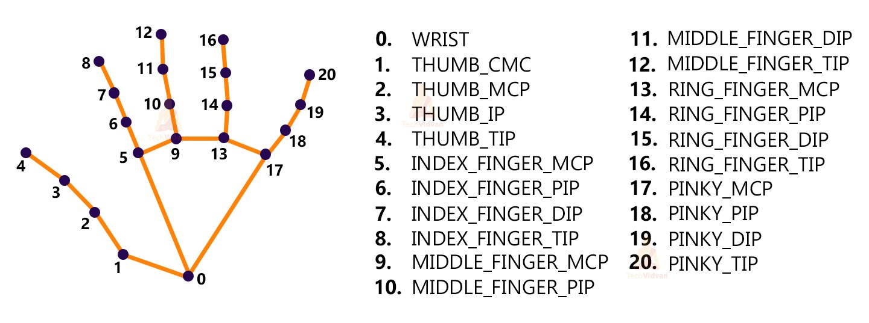

These key points will be fed into a pre-trained gesture recognizer network to recognize the hand pose.

Steps to solve the project:

* Import necessary packages.
* Initialize models.
* Read frames from a webcam.
* Detect hand keypoints.
* Recognize hand gestures.

[‘okay’, ‘peace’, ‘thumbs up’, ‘thumbs down’, ‘call me’, ‘stop’, ‘rock’, ‘live long’, ‘fist’, ‘smile’]

